MIDGLEY-MURGATROYD-WATERHOUSE CONNECTIONS

William Midgley Richard Midgley b~1546===Jane Oldfield
Yeoman of Black Carre, Thornton WRY 1582 resided at Roebucks, Warley
| _______________________|___________________
John Midgley the elder | |
Of Headley, Bradforddale William Midgley==m1570==Christabel Oldfield==m1586==Richard
| |
____________________________________ William Midgley 1608 of Roebucks
| | |
John the younger Susan Midgley===John Murgatroyd+ William Midgley#
d. 1669 | of East Riddlesden Yeoman b. 1614, d. 1695
| | and The Hollins, Of Roebucks, Warley
| | Luddenden & Broadfold Hall, Booth
_______________________________________ | |
| | | |
Jonas Midgley Liv. 1703====Elizabeth Martha Frances =====================William Midgley^
Of Headley Hall, | | Halifax lawyer
Lord of Thornton | | b. 1651, d. 1701
William Midgley======Elizabeth Waterhouse ________________________________
Curate of Sowerby | of Whitley and Sheffield | | | |
Lord of Thornton | d. 1715 William Mary@ Susannah John
b ~1672, d 10 May 1706 | b. 1680 b. 1681 b. 1686
_________________________________________________ d. 1729
| | |
John Midgley*====Bathsheba Mary dsp 1704 Martha dsp 1735
Of Scholemoor Hollins, d. 1736 aged 8
d. 1730
+Descended from Lacy of Cromwellbotham and Soothill of Soothill. Older brother of Thomas Murgatroyd of Kershaw House, Midgley.
# A possible younger brother of Richard Midgley who in 1613 was a yeoman clothier at Roebucks, Warley.
^Of Yate House, Dean House and Broadfold Hall, Booth.
+ Resided Broadfold Hall, died at ‘Eddington’ which is in Kent, alternatively Edlington, S. Yorks.
@ Mary married Thomas Holdsworth (1680-1735) of Ashday Hall, Southowram.
*Sold the Headley Estate
Previous page: http://midgleywebpages.com/thornton.html
Also see: http://midgleywebpages.com/arms.html

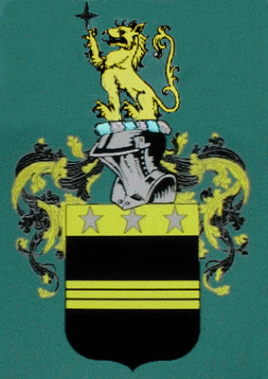 | 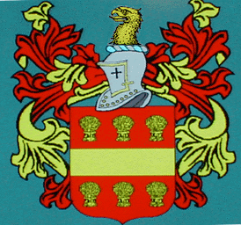
Arms of William Midgley curate of Sowerby and lord of Thornton in Bradforddale. b. ~ 1672, d. 1706. | Arms of William Midgley, lawyer of Halifax. b. 1651, d. 1701.

Revised 7th April 2021.

